Builds a Structure

🔧 What Does a Parser Do? → Builds a Structure
# Source: AI Source: Provided by: [Data Path: Persons Table -> ID Column: 1, Name_En Column: Motasem Essam] -> From: [Chatgpt (GPT‑5 Mini)] on [12/9/2025]
One of the core responsibilities of a parser is to build a structural representation of the input code — this structure is typically a:
- Parse Tree (full, detailed structure)
- or an
- Abstract Syntax Tree (AST) (simplified, essential structure)

🧱 1. Parse Tree (Concrete Syntax Tree)
# Source: AI Source: Provided by: [Data Path: Persons Table -> ID Column: 1, Name_En Column: Motasem Essam] -> From: [Chatgpt (GPT‑5 Mini)] on [12/9/2025]
A parse tree shows every single step the grammar takes to derive the input. It includes all non-terminals, terminals, and rules.
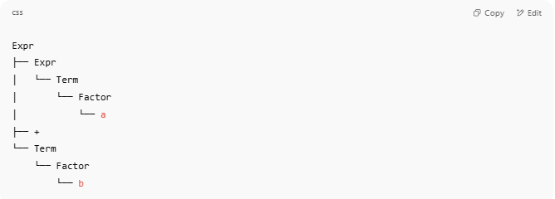

Example: Input = a + b
# Source: AI Source: Provided by: [Data Path: Persons Table -> ID Column: 1, Name_En Column: Motasem Essam] -> From: [Chatgpt (GPT‑5 Mini)] on [12/9/2025]
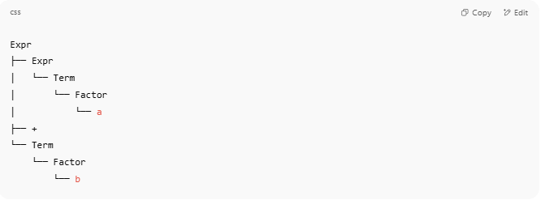
Expr
├── Expr
│ └── Term
│ └── Factor
│ └── a
├── +
└── Term
└── Factor
└── b

✅ Detailed structure showing how rules expand from the start symbol (Expr)

🪵 2. Abstract Syntax Tree (AST)
# Source: AI Source: Provided by: [Data Path: Persons Table -> ID Column: 1, Name_En Column: Motasem Essam] -> From: [Chatgpt (GPT‑5 Mini)] on [12/9/2025]
An AST strips away the grammar rules and focuses on the essential meaning of the code — it's more compact and closer to what the compiler actually uses for execution.

AST for a + b:
# Source: AI Source: Provided by: [Data Path: Persons Table -> ID Column: 1, Name_En Column: Motasem Essam] -> From: [Chatgpt (GPT‑5 Mini)] on [12/9/2025]
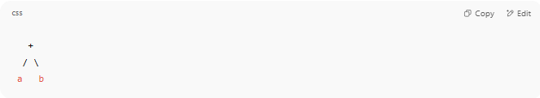
+
/ \
a b

✅ Minimal representation: no extra symbols, just core expressions and operators

🤔 Why Build a Structure?
# Source: AI Source: Provided by: [Data Path: Persons Table -> ID Column: 1, Name_En Column: Motasem Essam] -> From: [Chatgpt (GPT‑5 Mini)] on [12/9/2025]
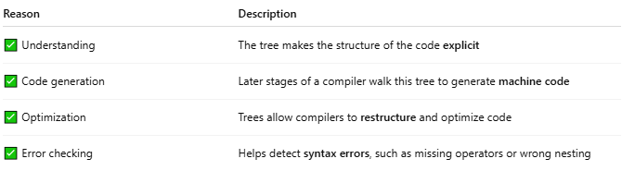
Reason | Description
✅ Understanding | The tree makes the structure of the code explicit
✅ Code generation | Later stages of a compiler walk this tree to generate machine code
✅ Optimization | Trees allow compilers to restructure and optimize code
✅ Error checking | Helps detect syntax errors, such as missing operators or wrong nesting

⚙️ Built During Syntax Analysis
# Source: AI Source: Provided by: [Data Path: Persons Table -> ID Column: 1, Name_En Column: Motasem Essam] -> From: [Chatgpt (GPT‑5 Mini)] on [12/9/2025]
The structure is built by applying grammar rules — for example, if the grammar includes:
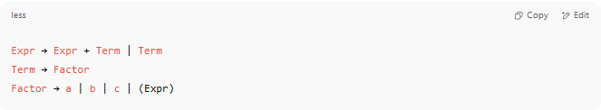
Expr → Expr + Term | Term
Term → Factor
Factor → a | b | c | (Expr)

The parser will match input to these rules and build a tree as it goes, either top-down (LL) or bottom-up (LR).

Real code example
# Source: AI Source: Provided by: [Data Path: Persons Table -> ID Column: 1, Name_En Column: Motasem Essam] -> From: [Chatgpt (GPT‑5 Mini)] on [12/9/2025]
Perfect! Let's build an Abstract Syntax Tree (AST) for a real code example — step by step — and visualize it.

🧪 Input Example: a + b * c
# Source: AI Source: Provided by: [Data Path: Persons Table -> ID Column: 1, Name_En Column: Motasem Essam] -> From: [Chatgpt (GPT‑5 Mini)] on [12/9/2025]
This is a simple arithmetic expression.
We’ll assume standard operator precedence:
- Multiplication (*) has higher precedence than addition (+).

📦 Step 1: Token Stream (from Lexical Analysis)
# Source: AI Source: Provided by: [Data Path: Persons Table -> ID Column: 1, Name_En Column: Motasem Essam] -> From: [Chatgpt (GPT‑5 Mini)] on [12/9/2025]
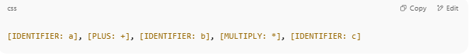
[IDENTIFIER: a], [PLUS: +], [IDENTIFIER: b], [MULTIPLY: *], [IDENTIFIER: c]

🌳 Step 2: Build the AST
# Source: AI Source: Provided by: [Data Path: Persons Table -> ID Column: 1, Name_En Column: Motasem Essam] -> From: [Chatgpt (GPT‑5 Mini)] on [12/9/2025]
We apply grammar rules and precedence:
a + (b * c)

🔨 AST Structure:
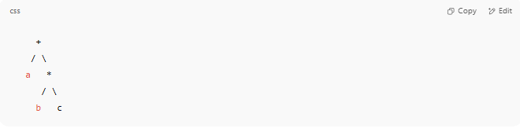
+
/ \
a *
/ \
b c

📌 Explanation of AST Nodes:
# Source: AI Source: Provided by: [Data Path: Persons Table -> ID Column: 1, Name_En Column: Motasem Essam] -> From: [Chatgpt (GPT‑5 Mini)] on [12/9/2025]
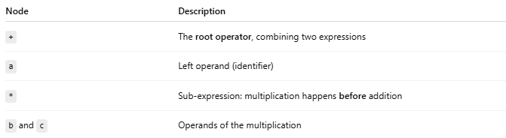
Node | Description
+ | The root operator, combining two expressions
a | Left operand (identifier)
* | Sub-expression: multiplication happens before addition
b and c | Operands of the multiplication

🎨 Visual Diagram (Text-Based)
# Source: AI Source: Provided by: [Data Path: Persons Table -> ID Column: 1, Name_En Column: Motasem Essam] -> From: [Chatgpt (GPT‑5 Mini)] on [12/9/2025]
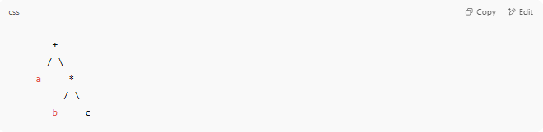
+
/ \
a *
/ \
b c

🛠️ Code Implementation (Python Example)
# Source: AI Source: Provided by: [Data Path: Persons Table -> ID Column: 1, Name_En Column: Motasem Essam] -> From: [Chatgpt (GPT‑5 Mini)] on [12/9/2025]
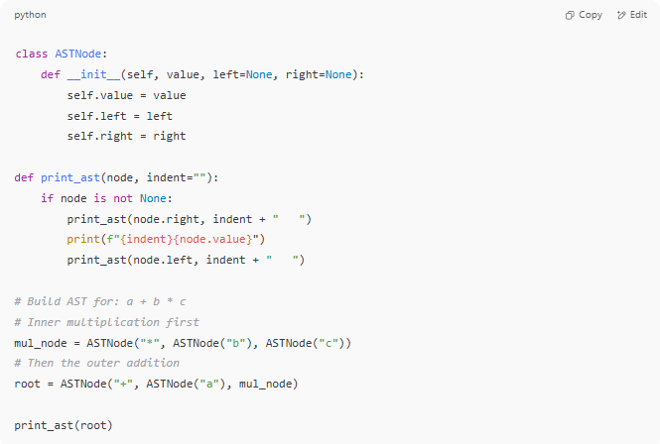
class ASTNode:
def __init__(self, value, left=None, right=None):
self.value = value
self.left = left
self.right = right

def print_ast(node, indent=""):
if node is not None:
print_ast(node.right, indent + " ")
print(f"{indent}{node.value}")
print_ast(node.left, indent + " ")

# Build AST for: a + b * c
# Inner multiplication first
mul_node = ASTNode("*", ASTNode("b"), ASTNode("c"))
# Then the outer addition
root = ASTNode("+", ASTNode("a"), mul_node)

print_ast(root)

✅ Output:
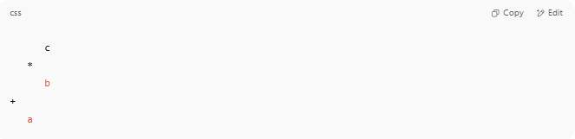
c
*
b
+
a

📌 Summary
# Source: AI Source: Provided by: [Data Path: Persons Table -> ID Column: 1, Name_En Column: Motasem Essam] -> From: [Chatgpt (GPT‑5 Mini)] on [12/9/2025]
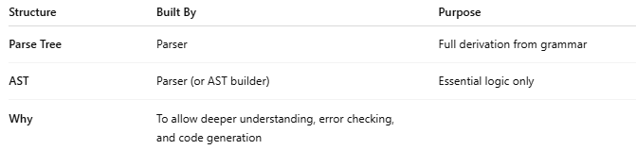
Structure | Built By | Purpose
Parse Tree | Parser | Full derivation from grammar
AST | Parser (or AST builder) | Essential logic only
Why | To allow deeper understanding, error checking, and code generation

